Landing page text

Once you click on “continue” you will be shown 50 questions.

30 are multiple choice, single word selections and you must choose the one that most describes you and the one that least describes you. Sometimes they may all seem to fit or all not fit, go with your first instinct or think about what someone who knows you well might say.

The next 20 are “true” or “false” statements.

The more honest you are the more accurate and so the more useful your results will be.

There are no 'right' or 'wrong' answers and no-one will see your responses.

There is no time limit but you should try and complete the assessment within 15 minutes if at all possible. You will be able to edit your answers as you go but once you click on the finish button you will not be able to return to the assessment or take a new one without a new log in.

The practitioner who sent out your log in will receive the resulting report and then pass it on to you. If you have any questions please call or email your registered MiRo practitioner or contact support@miro-assessment.com

After Q 30 text

That’s 30 questions down and just 20 to go.

Please answer true or false

Why are the “Question 45/50” legends highlighted green?

This

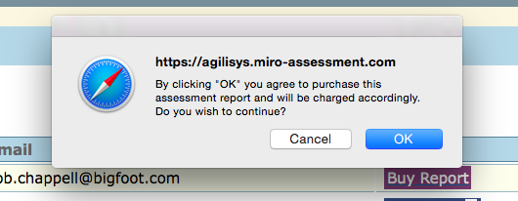

Should read

By clicking OK you are agreeing to buy this report

And this

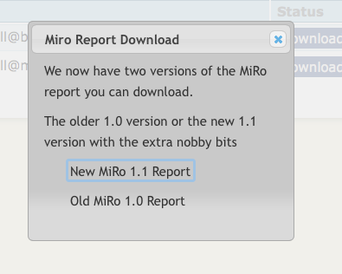

should read….

Download MiRo Report

Please choose which report you would like to download

MiRo Stage 1 (Standard report)

MiRo Stage 2 (Coaching report)

